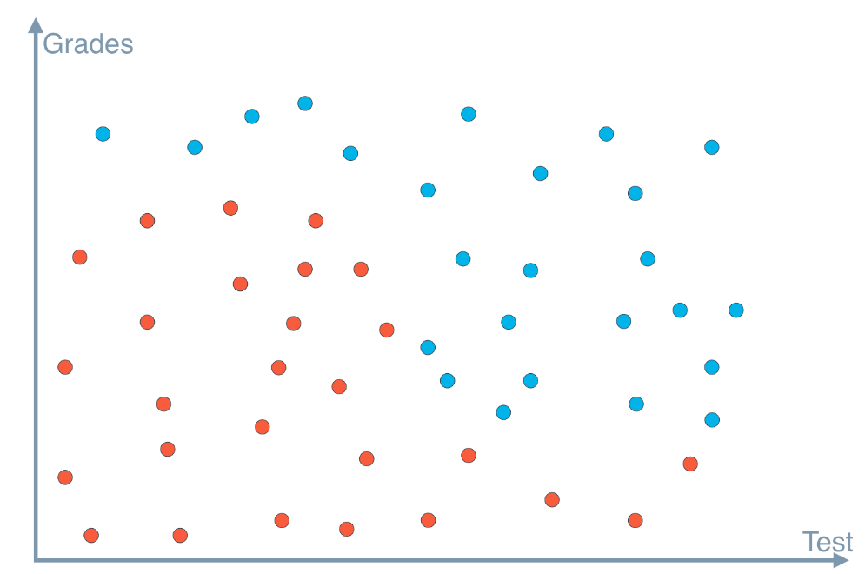

### Quiz Question

Between a horizontal and a vertical line, which one would cut the data better?

1. Horizontal
2. Vertical